HISPANIC HERITAGE MONTH
September 15 - October 15, 2019
2018 Theme: Hispanic Americans: A History of Serving Our Nation

National Hispanic Heritage Month is celebrated each September 15 - October 15 in the United States of America to recognize the contributions made by people of Hispanic descent and to celebrate Hispanic culture. It is celebrated on September 16, and recognizes the revolution in 1810 that ended the Spanish Dictatorship. The day of September 15 is significant because it is the anniversary of independence for Latin American countries Costa Rica, El Salvador, Guatemala, Honduras and Nicaragua. In addition, Mexico and Chile celebrate their independence days on September 16 and September18, respectively. Also, Columbus Day or Día de la Raza, which is October 12, falls within this 30 day period.

Hispanics have had a profound and positive influence on our country through their strong commitment to family, faith, hard work, and service. They have enhanced and shaped our national character with centuries-old traditions that reflect the multiethnic and multicultural customs of their community. The term Hispanic or Latino, refers to Puerto Rican, South or Central American, or other Spanish culture or origin regardless of race. On the 2010 Census form, people of Spanish, Hispanic and/or Latino origin could identify themselves as Mexican, Mexican American, Chicano, Puerto Rican, Cuban, or "another Hispanic, Latino, or Spanish origin."

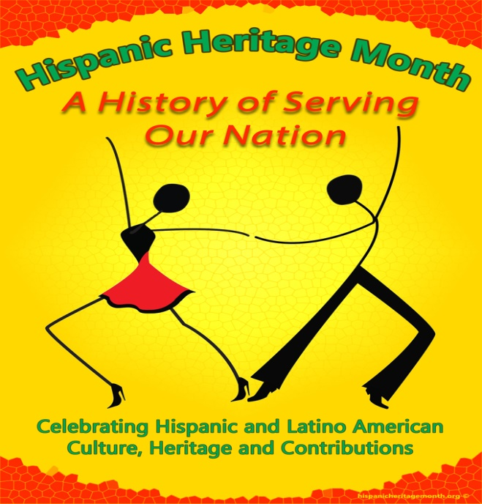

Did you know??
Today, 55 million people or 17% of the American population are of Hispanic or Latino origin. This represents a significant increase from 2000, which registered the Hispanic population at 35.3 million or 13% of the total U.S. population.

Fun facts:
Desi Arnaz was the first Hispanic American star of a network television show in 1952, starring in I Love Lucy.

Geraldo Rivera was Broadcaster of the Year in 1971.

Carlos Santana was inducted into the Rock & Roll Hall of Fame in 1998

Sources:
http://hispanicheritagemonth.gov/

https://www.infoplease.com/us/populationdemographics/famous-firsts-hispanic-americans

http://www.hispanicheritagemonth.org/

