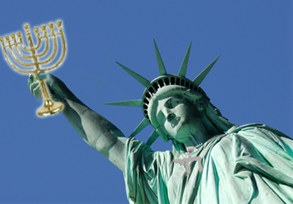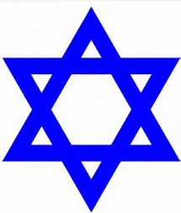

May is Jewish American Heritage Month. A month to celebrate the contributions Jewish Americans have made to America since they first arrived in New Amsterdam in 1654.

Jewish American Heritage Month had its origins in 1980 when Congress passed Pub. L. 96-237 which authorized and requested the President to issue a proclamation designating a week in April or May as Jewish Heritage Week. President Carter issued this first proclamation wherein he spoke about the bountiful contributions made by the Jews to the culture and history of the United States. He also spoke of the significance of April 1980 in the Jewish calendar, which was the anniversary of the Warsaw Ghetto Uprising, Israeli Independence Day, and the Days of Remembrance of Victims and Survivors of the Holocaust.

Between 1981 and 1990, Congress annually passed public laws proclaiming a week in April or May as Jewish Heritage Week and Presidents Reagan and George H.W. Bush issued annual proclamations which detailed important events in the history of the Jews.

Between 1995 and 2006, Presidents Clinton and George W. Bush issued a series of annual presidential proclamations designating a week in April or May of each year as Jewish Heritage Week. On April 24, 1998, President Clinton issued Presidential Proclamation 7087 which celebrates the many contributions of Jewish Americans along with the 50th Anniversary of the founding of the state of Israel.

There has been a Jewish presence in America since the colonial period. The most famous first communities of Jews settled in New York City; Charleston, South Carolina; and Newport, Rhode Island. Since then, Jews have thrived in the United States, developing their own communities while being an integral part of the development of American society as a whole.

In religious life, the American Jewish community has created some unique brands of Judaism. While Orthodox, Conservative, and Reform Judaism all have roots outside of the United States, each has formed its own style in America.

Did you know??

** Jews have had a remarkable influence on Hollywood and American popular culture as a whole. Perceptions of Jewish life and culture in America have been highly influenced by movies, televisions, books. Here are some notable Jewish American people who have made significant contributions over the years:
Barbara Streisand, Actress, Singer, Director, Producer
Steven Spielberg, Director, Producer
Albert Einstein, Physicist
Bernie Sanders, Politician
Ruth Bader Ginsburg, Supreme Court Justice
Sandy Koufax, Baseball Player
Mark Zuckerberg, CEO of Facebook

**The Star of David is a generally recognized symbol of Jewish Identity and Judaism.

Jewish in St. Louis

To learn more about the local Jewish Community and to stay abreast for what’s new and happening in St. Louis, please visit “Jewish in St. Louis” at https://jewishinstlouis.org/.

How About at Tasty Treat – Challah Bread!

Challah Bread is a special bread in Jewish Cuisine, usually braided or typically eaten on ceremonial occasions such as Shabbot and other major Jewish holidays, except for Passover. It’s delicious all by itself or you may consider trying it with hummus and/or olive tapenade!! For a sample recipe, please visit https://www.food.com/recipe/challah-bread-470590 if you would like to make your own Challah!

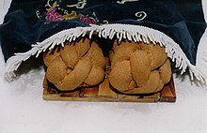

Sources:

- http://www.jewishheritagemonth.gov/about/
- Jewish American History, in Wikipedia, Retrieved May 16, 2017, From https://en.wikipedia.org/wiki/Jewish_American_Heritage_Month
- Star of David, in Wikipedia, Retrieved May 16, 2017, From https://en.wikipedia.org/wiki/Star_of_David
- http://blogs.bellevue.edu/library/index.php/2017/05/jewish-american-heritage-month/
- https://en.wikipedia.org/wiki/Challah, retrieved April 28, 2020
- http://www.myjewishlearning.com/article/jewish-american-heritage-month/

