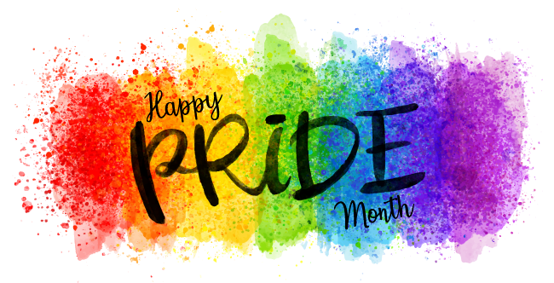
DID YOU KNOW
Lesbian, Gay, Bisexual and Transgender Pride Month is celebrated annually in June to honor the 1969 Stonewall riots and works to achieve equal justice and equal opportunity for lesbian, gay, bisexual, transgender, and questioning (LGBTQ) Americans.
In June of 1969, patrons and supporters of the Stonewall Inn in New York City staged an uprising to resist the police harassment and persecution to which LGBT Americans were commonly subjected. This uprising marks the beginning of a movement to outlaw discriminatory laws and practices against LGBT Americans.
Memorials are held during this month for those members of the community who have been lost to hate crimes or HIV/AIDS. The purpose of the commemorative month is to recognize the impact that LGBTQ individuals have had on history locally, nationally, and internationally.
As a result, many pride events are held during this month. Bisexual activist Brenda Howard is known as the “Mother of Pride”, for her work in coordinating the first LGBT Pride march, and she also originated the idea for a week-long series of events around Pride Day which became the genesis of the annual LGBT Pride celebrations that are now held around the world every June.

COME & CELEBRATE
This year Pride celebrations will look a little different because of the COVID-19 pandemic. Some have been postponed until later in the year, but Tower Grove Pride will be hosting a parade a Pride Care-A-Van from noon to 3 p.m. on June 28. The caravan will allow people to decorate their cars and drive through St. Louis as "a safe and responsible way for us to come together," according to the Facebook event. Register your vehicle beforehand to join the fun! The route map will be announced closer to the date.

MARK YOUR CALENDARS
The annual St. Louis PrideFest has been rescheduled for August 15 and 16, with the Pride Parade happening at noon on the 16th. It still plans to have an assortment of vendors and entertainment, though the specifics have yet to be released. It will also keep its location: the parks across from City Hall and Market Street, between N. 15th and N. Tucker streets. Admission will be free, but a $5 donation is encouraged.
Tower Grove Pride has also been rescheduled for August; specifically, 11 a.m. to 6 p.m. on August 29 at Tower Grove Park.
For those outside the city, St. Charles Pride Festival will begin at noon on October 3 at the Family Arena. Its second annual parade will happen nearby, along Frontier Park on Main Street. The festival and parade will both be free, and feature vendors both inside and outside the arena.
Metro East Pride Fest is rescheduled until Saturday, August 1.

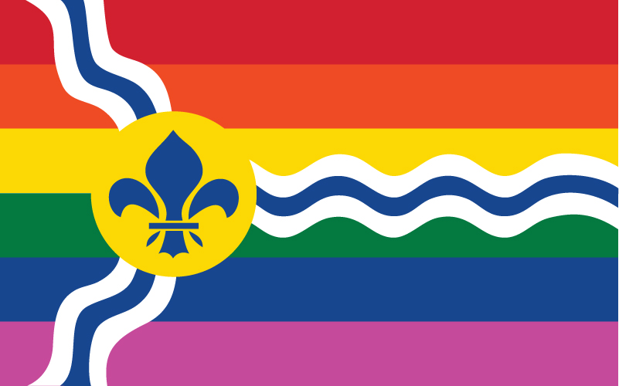

SOURCES
- https://en.wikipedia.org/wiki/Gay_pride#:~:text=LGBT%20Pride%20Month%20occurs%20in,have%20had%20in%20the%20world.
- https://youth.gov/feature-article/june-lgbt-pride-month
- https://www.stlmag.com/news/pride-round-up/

