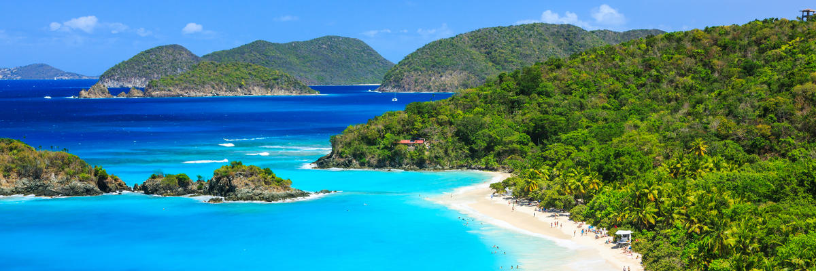

DID YOU KNOW
The campaign to designate June as National Caribbean American Heritage Month was spearheaded by Dr. Clair Nelson, Founder and President of the Institute of Caribbean Studies. Through the commemoration of this month, we hope to ensure that America is reminded that its greatness lies in its diversity, with Caribbean immigrants from founding father Alexander Hamilton, to journalist Malcolm Gladwell, who have shaped the American Dream.
From America’s earliest days, Caribbean Americans have contributed to the success, spirit, and character of our Nation. For generations, their skills, knowledge, innovation, and initiative have enhanced and advanced many aspects of our society. During National Caribbean-American Heritage Month, we celebrate the rich history and vibrant culture of the more than 4 million Americans with origins in the Caribbean.
Caribbean Americans have helped improve our Nation by leading communities, advancing science and medicine, and advocating for the common good. We are especially grateful for the Caribbean-American men and women who proudly wear our Nation’s uniform as members of the Armed Forces and those serving as first responders, medical professionals, and other essential personnel on the front lines in the fight against the coronavirus. Our Nation is safer, stronger, and healthier because of their service and sacrifices.
FAMOUS CARIBBEAN AMERICANS
Roberto Clemente: Hall of Fame Baseball Player and United States Marine
Sidney Poitier: First African American actor to receive an Academy Award
James Weldon Johnson: Harlem Renaissance poet and author of the Black National Anthem, Lift Every Voice and Sing
Shirley Chisholm: First African American congresswoman and the first black woman to run for President
Juan Carlos Finlay: Discovered Yellow Fever was transmitted by the Stegomyia aegypti mosquito
Oscar de la Renta: Fashion designer
Malcolm X: Late Nation of Islam spokesman
Colin Powell: First black U.S Secretary of State
John Russwurm: First black editor of a U.S. newspaper and one of the first three blacks to graduate from a U.S. college
Antonia Novello: First female U.S. Surgeon General
Constance Baker Motley: First black woman appointed to the federal bench
Dr. William Thornton: Physician and Architect who designed the U.S. Capitol

FAVORITE CARIBBEAN RECIPE: JERK CHICKEN
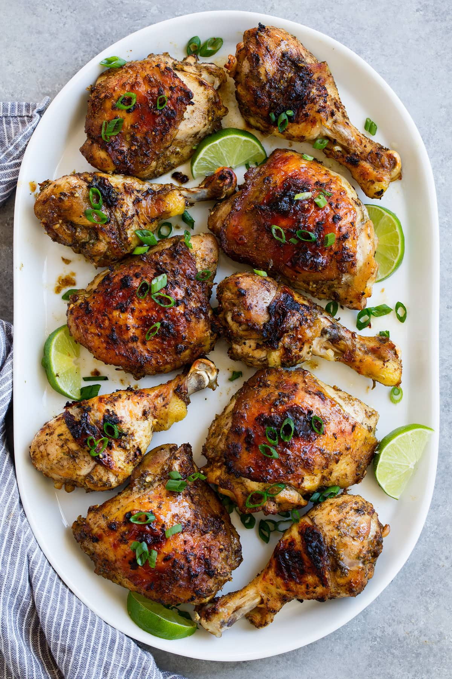

- 10 bone-in skin on chicken pieces, thighs and legs (about 3 lbs), trim excess fat and skin
- 6 green onions, cut into 2-inch pieces*
- 4 garlic cloves, peeled and smashed
- 2 habanero peppers (or scotch bonnet), stem removed**
- 1 1/2 -inch piece ginger, peeled and sliced
- 1/3 cup fresh lime juice
- 1/4 cup soy sauce
- 1 1/2 Tbsp brown sugar
- 1 Tbsp fresh thyme leaves
- 1 tsp freshly ground black pepper
- 1 tsp ground allspice
- 1/2 tsp ground cinnamon
- 1/2 tsp ground nutmeg

Marinate chicken in above ingredients for at least 3 hours. Grill on medium high heat for 30 minutes or until chicken is cooked through.

SOURCES
https://bb.usembassy.gov/june-2020-national-caribbean-american-heritage-month/
https://caribbeanmonth.org/
https://www.sun-sentinel.com/news/trending/sflcaribbeanamericans-story.html
https://www.cookingclassy.com/jerk-chicken/

