Life, Liberty & the Pursuit of Happiness 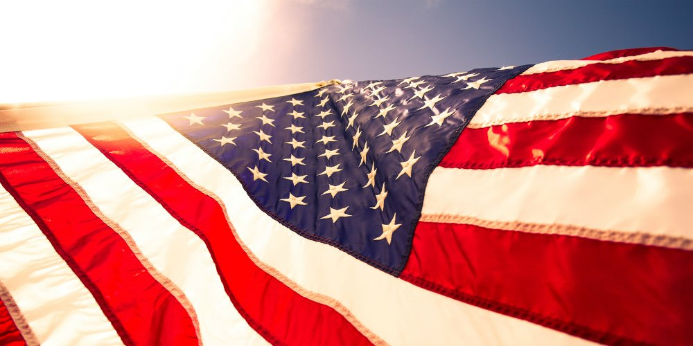
On July 4, 2020, the United States of America commemorated its 244 years of Independence. As much as this is the moment of pride and celebration for every American, this year's festivity was affected by two significant developments: a worldwide pandemic known as COVID-19 and civil unrest within this great nation.

As much as the protests took the spotlight and highlighted the hidden racism within the country's societal core, so did the pandemic play a pivotal role in dividing up the public's thoughts. Both the events have unfortunately set out debate platforms on every level and dug up the buried divide and hurt feelings. Yet here we are, trying to keep our heads above water and feeling proud to be a part of this celebration, which means more than parades, fireworks, speeches, and all the history associated with it.

Why the Independence matters to all of us, why do we celebrate it year after year? Is it just to celebrate that one day, or to remember the people who sacrificed themselves for it, or is it more than that? To understand the significance of Independence, we should familiarize ourselves with the word 'Freedom.' The word Freedom originated from Old English word freedom "power of self-determination, state of free will; emancipation from slavery, deliverance."

So, being Independent means being Free, and without Freedom, Independence loses its meaning. We celebrate our Freedom and all the symbolic things associated with our Independence because that rightfully gives Life, Liberty, and Pursuit of Happiness to the rest of our 364 days as a citizen or as an immigrant. Undoubtedly, Freedom is essential, but it should not be born out of having the freedom to give hate speeches, freedom to degrade based on race, freedom to mock someone over a different point of view, sexual preference, or openness to accept change over time. Freedom should allow us to breathe free. It should free us from negativity, hatred, or prejudices, narrow-mindedness and, above all, make us a better citizen/resident of this beautiful country. It may be that this mindset became the reason for Thomas Jefferson to put the finishing touches on the "Declaration of Independence" and to sever ties with a British colony. More than that, this document masterfully created a vision for America's future — one we still strive to live by 243 years later.

On this note, let us celebrate the 243 years of Independence that has made us the Free People of the United States of America and vow to unite all the States of our minds and make this great nation, an Improved Nation.
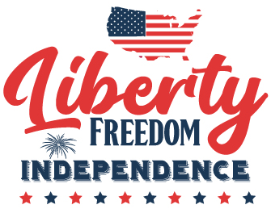
References:

https://www.etymonline.com/word
https://nationaltoday.com/independence-day/

